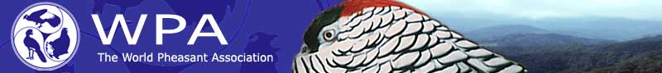
4th INTERNATIONAL GALLIFORMES SYMPOSIUM
CHENGDU, SICHUAN, CHINA - 14-21 OCTOBER 2007

Abstract Form (for return by 15 May 2007)
EXAMPLE:
TITLE | MANAGEMENT OF GALLIFORMES IN AGRICULTURAL LANDSCAPES
Names | John P Quail¹, Peter Pheasant² and Dick Partridge²
Addresses | 1 Department of Gamebirds, Bobwhite University, Amherst, Golden State 123 456, Galliformland; 2 Pheasant Savers International, 42 Arborophila Road, Monal Province, Tragopania.
Abstract  (max 250 words) | Please type your text in the relevant sections below, keeping within the allowed space. The title of your contribution should be in capital letters. Put your name and those of any co-authors (without titles and with first names in full), followed by numbers for each author to indicate addresses. Addresses should follow each of these numbers in the next section. Please do not type any text outside of the box provided and do not exceed 250 words (excluding title, authors and addresses). Please follow this example precisely so that we can include your abstract in the abstract booklet. We may wish to reword your abstract to make it easier to understand, but will ask you to approve any new version before it is finalised.

YOUR ABSTRACT:
TITLE

Names
Addresses
Abstract
(max 250 words)

PREFERRED TYPE OF CONTRIBUTION (click to select): Poster Talk

Please return to: Dr Stephen Browne, Chair Symposium Scientific Committee stephen.browne@fauna-flora.org

